Project Design Phase-II
Technology Stack (Architecture & Stack)

Date | 3 October 2026
Team ID | SWTID-2026-3708
Project Name | Streamlining IT Procurement: Automating Standard Laptop Orders with Flow Designer
Maximum Marks | 4 Marks

Technical Architecture:
The Deliverable shall include the architectural diagram as below and the information as per the table1 & table 2
Technical architecture of the Standard Laptop order automation (ServiceNow Flow Designer)
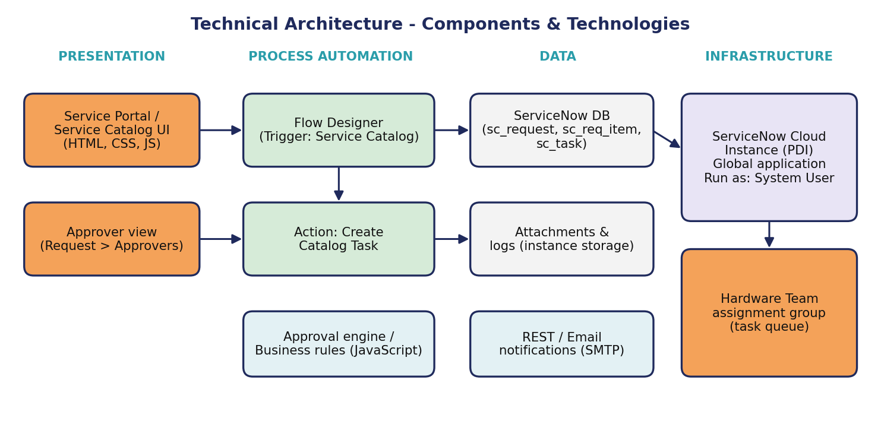

Table-1 : Components & Technologies:
S.No | Component | Description | Technology
 | User Interface | Employee, approver and Hardware team interact with the platform through the browser: Service Catalog (Hardware > Standard Laptop), Request / Requested Item forms and the task form. | ServiceNow Service Portal / Next Experience UI (HTML, CSS, JavaScript)
 | Application Logic-1 | Flow 'Standard Laptop task' with a Service Catalog trigger (Global application, runs as System User). | ServiceNow Flow Designer
 | Application Logic-2 | Create Catalog Task action; sets short description, description, assignment group (Hardware) and approval (Approved). | ServiceNow Core spoke action
 | Application Logic-3 | Approval handling for the request (Approvers tab) and flow assignment through the catalog item's Process Engine tab. | ServiceNow approval engine / Process Engine
 | Database | Request (sc_request), Requested Item (sc_req_item), Catalog Task (sc_task) and user group records. | ServiceNow relational database
 | Cloud Database | Database hosted by the ServiceNow cloud instance; no separate cloud database service is used. | ServiceNow cloud instance database
 | File Storage | Attachments (if any) stored with the records on the instance. | ServiceNow attachment storage (sys_attachment)
 | External API-1 | Not required for the current scope. Platform email notifications can be added later. | ServiceNow email notifications (optional)
 | External API-2 | Not required for the current scope. Possible future use: inventory or vendor system integration. | REST API (future scope)
 | Machine Learning Model | Not used in this project. | Not applicable
 | Infrastructure (Server / Cloud) | Application deployment on cloud (ServiceNow instance).  Local Server Configuration: not required, accessed through a web browser.  Cloud Server Configuration: ServiceNow instance, Global application scope. | ServiceNow Cloud

Table-2: Application Characteristics:
S.No | Characteristics | Description | Technology
 | Open-Source Frameworks | ServiceNow is a proprietary platform; the interface uses open web standards. | HTML5, CSS3, JavaScript, REST / JSON
 | Security Implementations | Role-based access control and ACLs, approval step before fulfilment, flow runs as System User, audit logs of flow executions, encrypted HTTPS access. | ServiceNow roles and ACLs, TLS (HTTPS), audit logs
 | Scalable Architecture | Multi-tier platform (presentation, application, database). The flow is reusable for other catalog items and assignment groups. | ServiceNow multi-tier architecture, Flow Designer
 | Availability | Hosted on the ServiceNow cloud with platform-managed availability; the flow engine runs in the background without extra servers. | ServiceNow cloud platform
 | Performance | Task creation runs asynchronously so ordering stays fast; standard actions only, no custom scripts. | Flow Designer engine, platform caching and indexing

References:
https://c4model.com/
https://developer.ibm.com/patterns/online-order-processing-system-during-pandemic/
https://www.ibm.com/cloud/architecture
https://aws.amazon.com/architecture
https://medium.com/the-internal-startup/how-to-draw-useful-technical-architecture-diagrams-2d20c9fda90d

